**Title X Clinic Locations and their Relation to Income in Michigan**

Elizabeth Chambers and Harshpriya Gaikwad

**Abstract**

Family Planning organization are currently facing much criticism and turmoil. Rather than cutting services criticized by the government, many large organizations are opting out of the *Title X* federal grant program which aims to provide lower income individuals with access to reproductive health services. To determine whether or not Title X facilities are indeed accessible by lower income communities, this paper explores the relationship between family planning clinics and median household income by use of the Census Bureau API and Michigan’s Title X Family Planning Clinic Directory. The hypothesis that there is a relationship between income and locations of facilities was tested by use of a point-biserial correlation test, a logistic regression test, population proportions and graphical representation. The results were favorable in that the relationship between locations of clinics and median household income was found to be statistically significant, with clinics tending to be located in lower-income communities.

**Introduction**

Reproductive health services are vital in all communities, but does this mean people in every type of socioeconomic community have access to the reproductive healthcare they need? The “Title X Family Planning Program” is a federal grant that aims to provide low-income patients with family planning and reproductive health services. Recent amendments to the program have led to major organizations opting out of the “Title X” program, and thus a decline in low-income patients’ access to family planning and reproductive health services.

The nature of the “Title X Family Planning Program” should place Title X facilities within lower-income communities. The goal of this research project is to determine whether or not Title X clinics are indeed accessible by low-income families.

**Methods**

**Data**

The data utilized was taken from the United States Census Bureau API as well as the Michigan Department of Health & Human Services. The data extracted from the United States Census Bureau was from the “Small Area Income and Poverty Estimates (SAIPE)” API, which provides the best single-year estimates of median household income. Locations of family planning facilities in Michigan were taken from the “MDHHS Title X Family Planning Clinic Directory”.

In addition to this data, the Google Maps API was utilized in order to geocode the locations of Title X facilities as well as counties in Michigan which fall in the first and third quartile of income, and compare their locations visually.

**Procedure**

In order to determine whether or not there is a correlation between income and locations of Title X Clinics within Michigan, the median income for each county in Michigan was gathered by use of the *getCensus()* function, provided by the United States Census Bureau. The variables obtained from this API were time (the year that the data was collected), state (the state the data was collected in), county (the county number which the data was collected in), NAME (the name of the county), median.income (estimated median household income) and people.count (the number of people in poverty within that county) (See Appendix A).

Assuming a normal distribution for median household income, the *summary()* function was then used, to determine a threshold for which counties in Michigan should be considered “lower-income” (first-quartile) and which should be considered “higher-income” (third-quartile). The first-quartile was found to be <= $47,482 and the third-quartile was found to be >= $57,626. Using these bounds, the *mutate_geocode()* function was used to convert counties which fell in these categories into latitude and longitude coordinates in order to visually compare them to locations of Title X Facilities.

Next, a map was plotted, utilizing data provided by the *maps*, *mapsdata* and *ggplot* packages (see Apendix B):

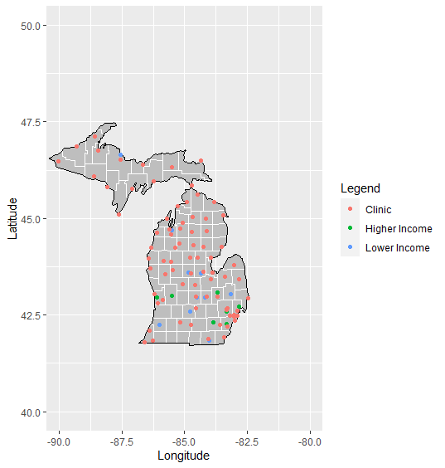

Figure 1

In order to better understand the relationship between income and locations of family planning clinics, a scatterplot depicting median household income for every county in Michigan with horizontal lines representing the 1st and 3rd quartile (respectively), colored by whether or not the county has a family planning clinic was created (see Appendix C):

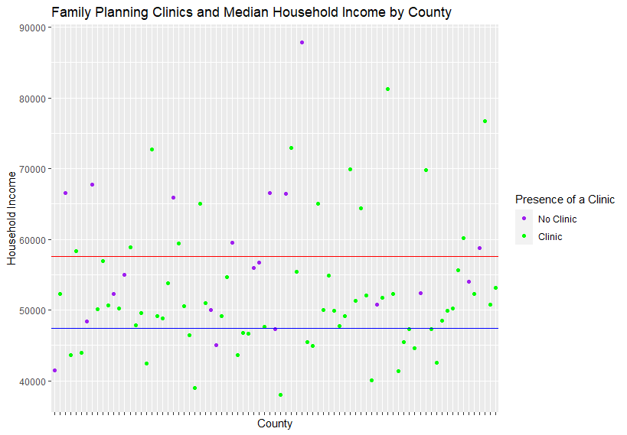

Figure

In addition to graphical representations of the data, a point-biserial correlation test and a logistic regression test were run in order to determine whether or not there is a relationship between median household income and presence of a Title X facility.

**Results**

**Point-biserial Correlation:**

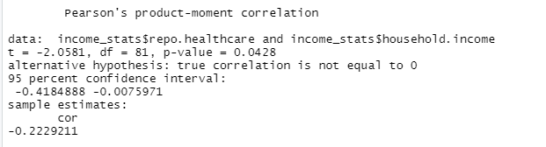

**Logistic Regression:**

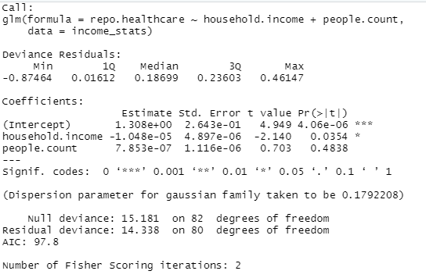

Looking at *Figure 1*, Title X clinics appear to be more densely populated in counties which have a median household income in the third quartile, while counties with a lower income appear to have sparse clinic locations. However, this could be due to higher county populations, as the clinics also appear to be situated around cities such as Detroit and Grand Rapids.

*Figure 2* shows that counties which have a clinic fall within a median income range of $40,000 to $70,000, with one outlier at about $89,000. *Figure 2* also shows that the population proportion of clinics located in a county where the median income falls in the 1st quartile is 18/79 (22.7% ), while the population proportion of clinics located in a county where the median income falls in the 3rd quartile is only 13/79 (16.4%).

Since the correlation coefficient of the point-biserialtest is negative (-0.2229211), this indicates that when a county has a Title X Clinic, the county’s income tends to be lower. Since the correlation coefficient is closer to 0 than 1, there is a weak negative linear relationship between median family income and the presence of a Title X facility. In addition to this, since the p-value is 0.0428 (<0.05), we can say that the relationship between median household income and the presence of a Title X facility in counties of Michigan is statistically significant.

The logistic regression test further solidifies the statistical significance of the relationship between median household income of counties in Michigan and the presence of a Title X facility, since the p-value is 0.0354 (<0.05) the median household income is significant in predicting whether or not there will be a Title X facility in that county.

**Conclusion**

Considering the results of the point-biserial correlation test and the logistic regression test, as well as the graphical interpretations of the data, we can conclude that the relationship between locations of Title X clinics in and median household income in Michigan is statistically significant. We can also conclude that the relationship between these variables is a weak, negative correlation, which means that clinic locations tend to favor lower-income areas, but are almost uniformly dispersed despite income. Finally, we can conclude that the *Title X Family Planning Program* is indeed providing reproductive healthcare to lower-income communities and the grant program is effective.

**Appendices**

**Appendix A:** R script for obtaining data from the United States Census Bureau API:

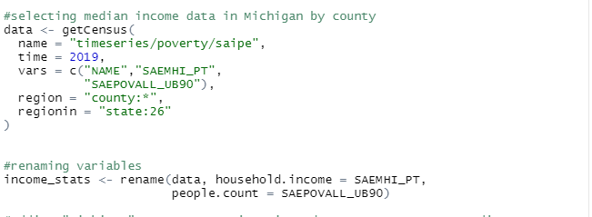

**Appendix B:** R script for a plot of Michigan depicting locations of Title X clinics and locations of counties within the 1st and 3rd quartile:

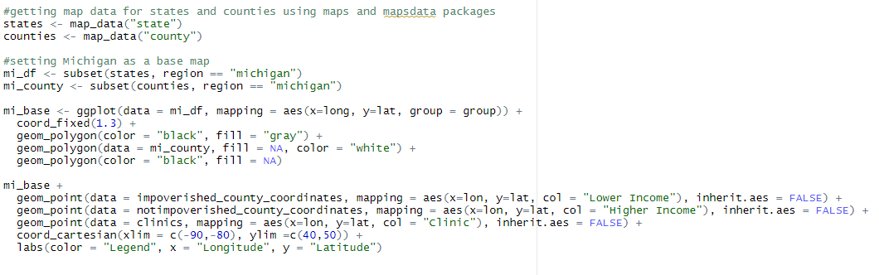

**Appendix C:** R script for a scatterplot detailing the distribution of Title X clinics in relation to the median income of counties in Michigan:

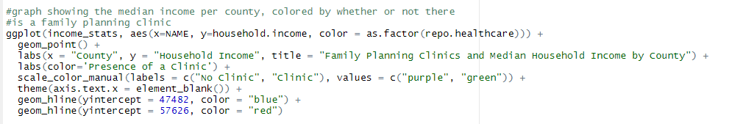

**References**

Bureau, U. (2017, November 30). Poverty statistics: Cps & SAIPE (Time SERIES: VARIOUS YEARS). Retrieved April 18, 2021, from https://www.census.gov/data/developers/data-sets/Poverty-Statistics.html

Wen, N. (2019, September 24). After title X Regulation Changes: Difficult questions for policymakers And Providers: Health AFFAIRS BLOG. Retrieved April 12, 2021, from <https://www.healthaffairs.org/do/10.1377/hblog20190923.813004/full/#:~:text=Started%20in%201970%2C%20the%20Title,breast%20and%20cervical%20cancer%20screenings>.

You are hereMDHHS Adult & CHILDREN'S services children & Families healthy children & healthy families. (n.d.). Retrieved April 18, 2021, from https://www.michigan.gov/mdhhs/0,5885,7-339-73971_4911_4912_6216_75529---,00.html